|  |  |
| --- | --- |
| **EXP NO: 1** | **WRITE A HTML PROGRAM FOR CREATION OF FORMS LINKS AND TABLES** |
| **DATE: 23/1/25** |

**AIM:**

To write a html program for creation of forms links and tables

**ALGORITHM:**

**Step 1:** Start the HTML document using <!DOCTYPE html> and open <html> and <head> tags. **Step 2:** Set the title of the webpage using the <title> tag inside <head>. **Step 3:** Open the <body> tag to begin adding visible content. **Step 4:** Create a form using the <form> tag with action and method attributes.  
**Step 5:** Add input fields such as <input type="text"> and <input type="email"> inside the form. **Step 6:** Include a submit button using <input type="submit">. **Step 7:** Create hyperlinks using <a href="URL">Link Text</a>.  
**Step 8:** Design a table using <table>, and add rows with <tr>, headers with <th>, and data with <td>. **Step 9:** Close all opened tags properly: </form>, </table>, </body>, and </html>.  
  
**SOURCE CODE:**

<!DOCTYPE html>

<html>

<head>

<title>HTML Forms, Links, and Tables Example</title>

<style>

body {

font-family: Arial, sans-serif;

margin: 20px;

}

table {

border-collapse: collapse;

width: 60%;

margin-top: 20px;

}

table, th, td {

border: 1px solid #444;

}

th, td {

padding: 10px;

text-align: left;

}

form {

margin-bottom: 20px;

}

</style>

</head>

<body>

<h2>Registration Form</h2>

<form action="#" method="post">

<label for="name">Name:</label><br>

<input type="text" id="name" name="name" required><br><br>

<label for="email">Email:</label><br>

<input type="email" id="email" name="email" required><br><br>

<input type="submit" value="Register">

</form>

<h2>Useful Links</h2>

<ul>

<li><a href="https://www.w3schools.com" target="_blank">Visit W3Schools</a></li>

<li><a href="https://www.mozilla.org" target="_blank">Visit Mozilla</a></li>

</ul>

<h2>Participant Table</h2>

<table>

<tr>

<th>S.No</th>

<th>Name</th>

<th>Email</th>

</tr>

<tr>

<td>1</td>

<td>Alice Johnson</td>

<td>alice@example.com</td>

</tr>

<tr>

<td>2</td>

<td>Bob Smith</td>

<td>bob@example.com</td>

</tr>

</table>

</body>

</html>

**OUTPUT:**

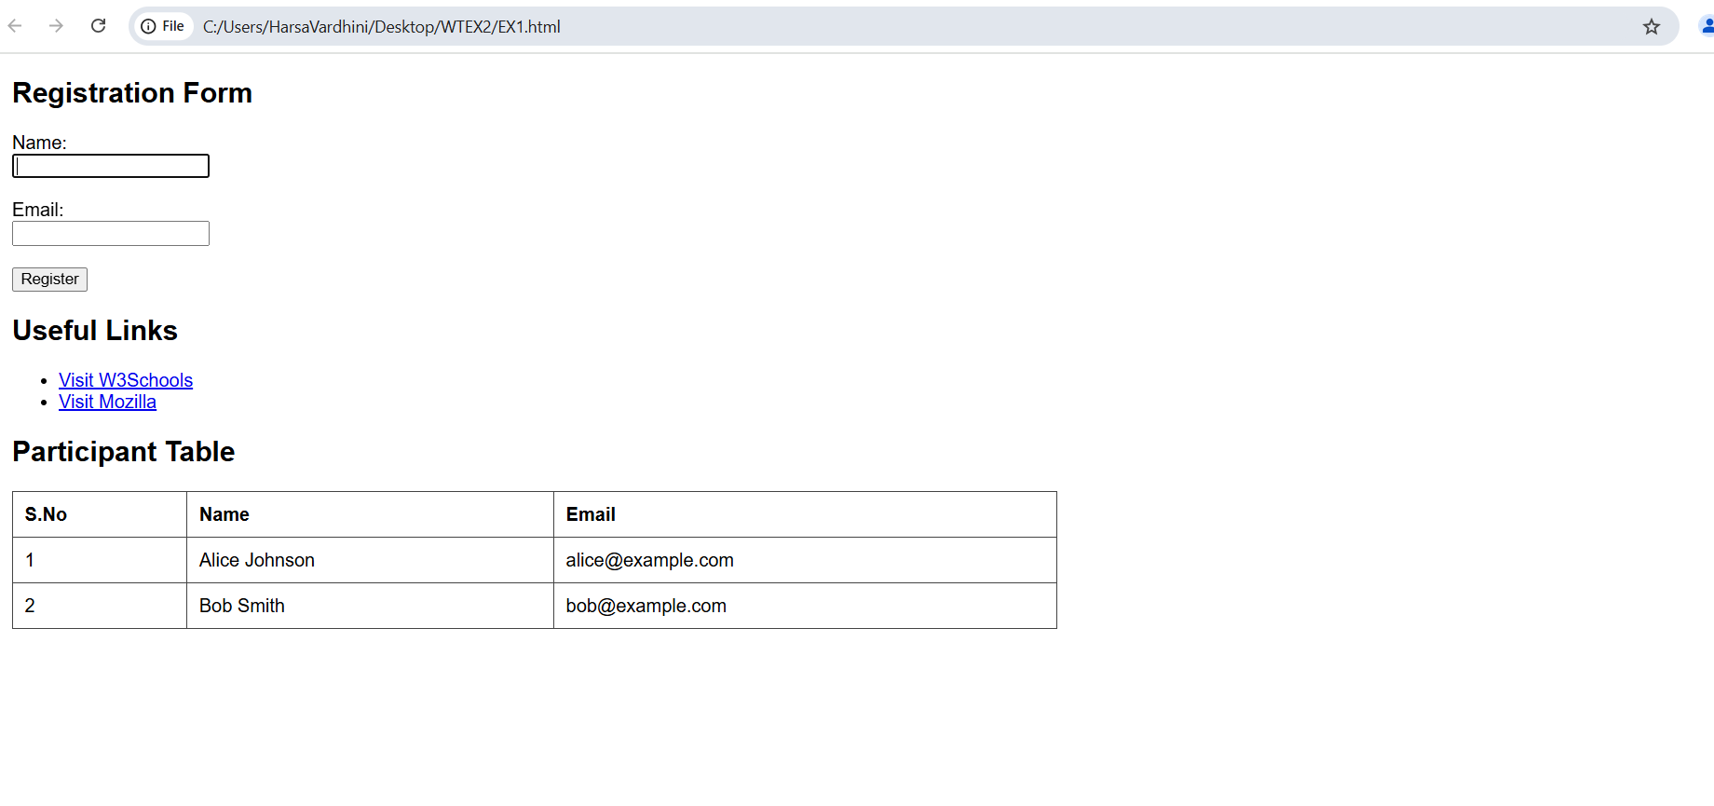

**RESULT:**

  Thus, the HTML webpage containing hyperlinks, forms, and tables is successfully created.The functionalities were implemented and verified with proper structure and formatting using basic HTML tags.

|  |  |
| --- | --- |
| **EXP NO: 2** | **DESIGN A WEBSITE USING HTML TO CREATE A BASIC TEXT FORMATTING , IMAGES .** |
| **DATE: 30/1/25** |

**AIM:**

To create a website using html to create a basic textformatting and images

**ALGORITHM:**

**Step 1:** Start the HTML document using <!DOCTYPE html> and open <html>, <head>, and <body> tags. **Step 2:** Set the character encoding and viewport settings using <meta> tags inside <head>. **Step 3:** Add the title of the webpage using the <title> tag. **Step 4:** Create a main heading using the <h1> tag. **Step 5:** Add multiple paragraphs using <p>, and apply formatting tags like <b>, <i>, <u>, <mark>, <del>, and <small>. **Step 6:** Insert a subheading using <h2> and display an image using the <img> tag with src and alt attributes. **Step 7:** Create another subheading and add a hyperlink using the <a> tag with href and target="_blank". **Step 8:** Add a bulleted list using the <ul> tag with items inside <li> tags. **Step 9:** Close all opened tags properly, including </body> and </html>.  
  
**SOURCE CODE:**<!DOCTYPE html>

<html lang="en">

<head>

    <meta charset="UTF-8">

    <meta name="viewport" content="width=device-width, initial-scale=1.0">

    <title>Welcome to My Creative Webpage</title>

</head>

<body>

    <!-- Heading -->

    <h1>Discover the Beauty of Simplicity</h1>

    <!-- Paragraphs with text formatting -->

    <p><b>Welcome</b> to a space where creativity meets simplicity. This webpage showcases how <i>beautiful design</i> can be achieved with <u>basic HTML elements</u>.</p>

    <p>Every great journey begins with a single step. Just like <mark>every well-crafted webpage</mark> starts with a structured layout and a creative touch.</p>

    <p><b><i>Innovation</i></b> is not about complexity; it's about making things <small>meaningful</small> and <b>impactful</b>. <del>Overthinking</del> is unnecessary—just start building!</p>

    <!-- Image -->

    <h2>A Glimpse of Elegance</h2>

    <img src="https://tse3.mm.bing.net/th?id=OIP.DXTzA53g5h_MlYhHIt7IEwHaFj&pid=Api&P=0&h=180" alt="Beautiful Landscape">

    <!-- Hyperlink -->

    <h2>Stay Inspired</h2>

    <p>Explore more amazing content at <a href="https://www.example.com" target="_blank">Example Website</a> and keep learning!</p>

<!-- List -->

    <h2>Keys to a Stunning Webpage</h2>

    <ul>

        <li>Minimalism - Less is more.</li>

        <li>Typography - Choose fonts wisely.</li>

        <li>Visual Balance - Keep it clean and structured.</li>

    </ul>

</body>

</html>

**OUTPUT:**  
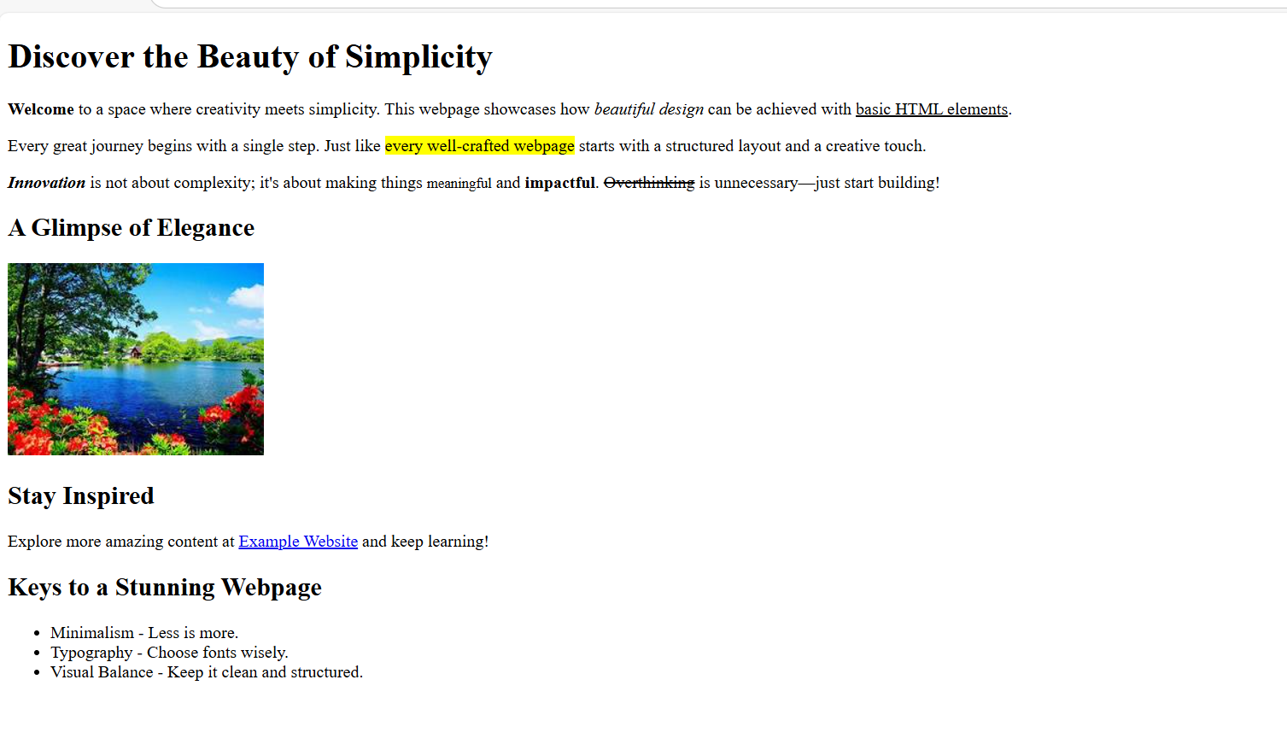  
**RESULT:**

   Thus, the HTML webpage title is successfully created. It demonstrates the use of text formatting tags, image embedding, hyperlinks, and unordered lists to build a clean and creative webpage layout using basic HTML elements.

|  |  |
| --- | --- |
| **EXP NO: 3** | **CREATE A WEBPAGE WITH HTML5** |
| **DATE: 6/2/25** |

**i)To embed an image in a webpage**

**ii)To fix the hotspot**

**iii)Show all the related information when the hotspot is clicked**

**AIM:**

To create a webpage using HTML5 that embeds an image with interactive hotspots and displays related information upon clicking them.

**ALGORITHM:**

**Step 1:** Start the HTML document with <!DOCTYPE html> and open <html> and <head> tags. **Step 2:** Set the character encoding and viewport using <meta> tags inside the <head> tag. **Step 3:** Define the title of the webpage with <title> tag. **Step 4:** Inside the <body>, use the <img> tag to embed the image and define the usemap attribute linking it to the image map. **Step 5:** Define an image map using the <map> tag with a unique name and add <area> tags inside it. **Step 6:** Set the coordinates of each hotspot using the coords attribute of the <area> tag and specify the href attribute to link to the related information.  
**Step 7:** Ensure the image map’s defined regions are clickable and properly configured to display or redirect information when clicked.  
**Step 8:** Close all the tags properly with </body> and </html>.

**SOURCE CODE:**<!DOCTYPE html>

<html lang="en">

<head>

    <meta charset="UTF-8">

    <meta name="viewport" content="width=device-width, initial-scale=1.0">

    <title>Image Map</title>

</head>

<body>

    <h1>Interactive World Map</h1>

    <p>Click on different continents to learn more.</p>

    <!-- Image with an image map -->

    <img src="https://thumbs.dreamstime.com/b/high-resolution-world-map-landforms-detailed-satellite-view-earth-its-global-elements-image-furnished-nasa-87502492.jpg" usemap="#worldmap" width="800" alt="World Map">

    <!-- Image Map Definition -->

    <map name="worldmap">

        <!-- Europe -->

        <area shape="rect" coords="350,80,450,180" href="https://en.wikipedia.org/wiki/Europe" target="_blank" alt="Europe">

        <!-- Asia -->

        <area shape="rect" coords="460,80,660,280" href="https://en.wikipedia.org/wiki/Asia" target="_blank" alt="Asia">

        <!-- Africa -->

        <area shape="rect" coords="370,200,500,380" href="https://en.wikipedia.org/wiki/Africa" target="_blank" alt="Africa">

        <!-- North America -->

        <area shape="rect" coords="50,50,250,250" href="https://en.wikipedia.org/wiki/North_America" target="_blank" alt="North America">

        <!-- South America -->

        <area shape="rect" coords="180,280,300,450" href="https://en.wikipedia.org/wiki/South_America" target="_blank" alt="South America">

        <!-- Australia -->

        <area shape="rect" coords="650,320,780,450" href="https://en.wikipedia.org/wiki/Australia" target="_blank" alt="Australia">

    </map>

    <p>Clicking on any hotspot will take you to Wikipedia for more details about that continent.</p>

</body>

</html>

**OUTPUT:**

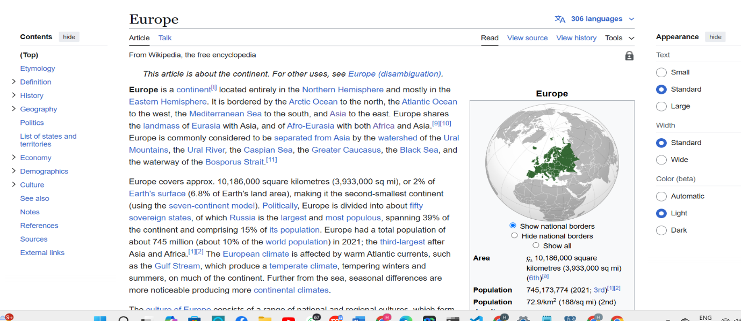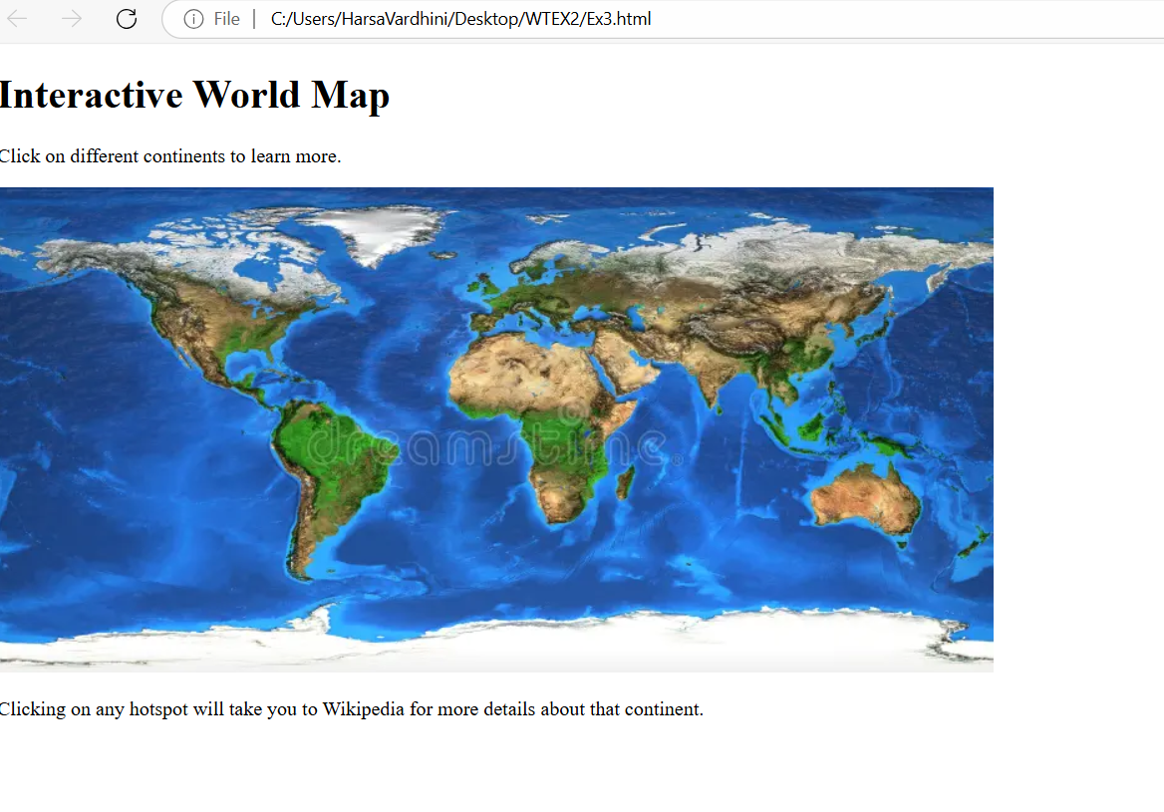

**RESULT:**

Thus, the HTML5 webpage with an embedded image map is successfully created.The interactive hotspots were defined and linked to show related information when clickeproviding a seamless user experience with clickable areas on the image.

|  |  |
| --- | --- |
| **EXP NO: 4** | **CREATE A WEBPAGE WITH ALL TYPES OF CSS** |
| **DATE: 13/2/25** |

**AIM:**

To design a professional webpage using **HTML5** and **CSS** (internal, external, and inline) that showcases various CSS features including styling, layout, and responsiveness.

**ALGORITHM:**

**Step 1:** Start the HTML document with <!DOCTYPE html> and open <html>, <head>, and <body> tags. **Step 2:** Set metadata such as character encoding and viewport using <meta> tags inside the <head>. **Step 3:** Define the title of the webpage using the <title> tag. **Step 4:** Link an external CSS file using the <link rel="stylesheet"> tag for global styles.  
**Step 5:** Add internal CSS inside <style> tags to customize specific elements like headings and spans. **Step 6:** Create a header section using <header> with a <h1> and <p> for the main title and subtitle. **Step 7:** Embed an image in the hero section using <img> and apply inline CSS for responsive sizing. **Step 8:** Overlay text on the hero image using a <div> with styled <h2> and <p> elements. **Step 9:** Add a content section with <h2> and <p> tags, using <span class="highlight"> to emphasize text. **Step 10:** Build a features section with multiple <div class="feature-box"> blocks describing key CSS topics. **Step 11:** Create a footer using <footer> and include a copyright notice. **Step 12:** Close all open tags (</body>, </html>) to complete the webpage structure.

**SOURCE CODE:**

<!DOCTYPE html>

<html lang="en">

<head>

    <meta charset="UTF-8">

    <meta name="viewport" content="width=device-width, initial-scale=1.0">

    <title>Professional CSS Webpage</title>

    <!-- External CSS -->

    <link rel="stylesheet" href="stylesex4.css">

    <!-- Internal CSS -->

    <style>

        h2 {

            color: #2a2a2b;

            text-align: center;

            margin-top: 30px;

            font-size: 28px;

        }

        .highlight {

            background-color: yellow;

            padding: 5px;

            font-weight: bold;

        }

    </style>

</head>

<body>

    <!-- Header Section -->

    <header>

        <h1>Welcome to the World of CSS</h1>

        <p>Mastering CSS for Modern Web Development</p>

    </header>

    <!-- Hero Section with Inline CSS -->

    <section class="hero">

        <img src="https://img.freepik.com/premium-photo/suspension-bridge-travel-nature-scenery-building_1417-264.jpg" alt="Web Design" style="width: 100%; height: auto;">

        <div class="hero-text">

            <h2 style="color: white; font-size: 35px;">CSS: The Heart of Web Styling</h2>

            <p style="color: white;">Discover how CSS enhances design, responsiveness, and animations.</p>

            <a href="#" class="btn">Explore More</a>

        </div>

    </section>

    <!-- Content Section -->

    <section class="content">

        <h2>Why Learn CSS?</h2>

        <p>CSS (Cascading Style Sheets) allows you to design professional web pages by <span class="highlight">adding styles, animations, and responsiveness</span>.</p>

        <p>With CSS, you can create visually appealing layouts and improve user experience.</p>

    </section>

    <!-- Features Section -->

    <section class="features">

        <div class="feature-box">

            <h3>CSS Selectors</h3>

            <p>Target elements with different selectors for precise styling.</p>

        </div>

        <div class="feature-box">

            <h3>CSS Grid & Flexbox</h3>

            <p>Create dynamic layouts with ease.</p>

        </div>

        <div class="feature-box">

            <h3>CSS Animations</h3>

            <p>Enhance UI with animations and transitions.</p>

        </div>

    </section>

    <!-- Footer -->

    <footer>

        <p>&copy; 2025 Professional CSS Webpage </p>

    </footer>

</body>

</html>

**OUTPUT:**



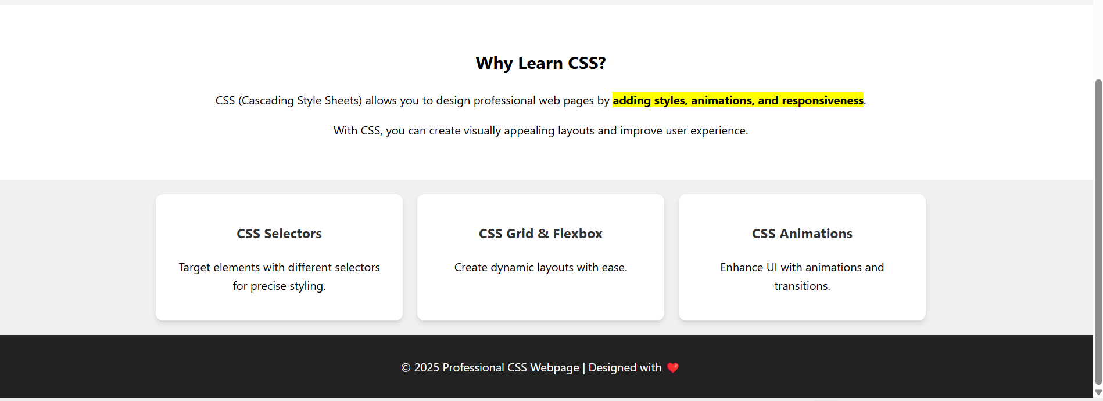

**RESULT:**

Thus, the professional HTML5 webpage integrated with internal, external, and inline CSS is successfully created.The webpage demonstrates structured layout, custom styling, and responsiveness, showcasing core concepts of CSS effectively.

|  |  |
| --- | --- |
| **EXP NO: 5** | **A SCIENTIFIC CALCULATOR USING HTML, CSS, AND JAVASCRIPT** |
| **DATE: 22/03/25** |

**AIM:**

To design a Scientific Calculator using HTML, CSS, and JavaScript.

**ALGORITHM:**

**Step 1:** Create the HTML structure with a display and calculator buttons.  
**Step 2:** Style the calculator layout and buttons using CSS for better user interface.  
**Step 3:** Implement appendToDisplay(value) to add clicked button values to the input field.  
**Step 4:** Implement clearDisplay() to reset the input display when needed.   
**Step 5:** Implement calculateResult() to evaluate the mathematical expression.   
**Step 6:** Use try-catch block in calculateResult() to handle invalid expressions.  
**Step 7:** Add scientific functions like sqrt, pow, sin, cos, tan, log, exp, and pi.  
**Step 8:** Assign onclick events to all calculator buttons to trigger JavaScript functions.

**SOURCE CODE:**

<!DOCTYPE html>

<html lang="en">

<head>

<meta charset="UTF-8">

<meta name="viewport" content="width=device-width, initial-scale=1.0">

<title>Document</title>

<style>

body {

display: flex;

justify-content: center;

align-items: center;

height: 100vh;

background-color: #f4f4f4;

}

.calculator {

width: 300px;

background: #fff;

padding: 20px;

border-radius: 10px;

box-shadow: 0 0 10px rgba(0, 0, 0, 0.1);

text-align: center;

}

input {

width: 100%;

height: 50px;

text-align: right;

font-size: 1.5em;

margin-bottom: 10px;

}

.buttons {

display: grid;

grid-template-columns: repeat(4, 1fr);

gap: 5px;

}

button {

height: 50px;

font-size: 1.2em;

border: none;

cursor: pointer;

background: #eee;

border-radius: 5px;

}

button:active {

background: #ddd;

}

.equal {

background: #28a745;

color: white;

}

.clear {

background: #dc3545;

color: white;

}

</style>

</head>

<body>

<div class="calculator">

<input type="text" id="display" disabled>

<div class="buttons">

<button onclick="clearDisplay()" class="clear">C</button>

<button onclick="appendToDisplay('(')">(</button>

<button onclick="appendToDisplay(')')">)</button>

<button onclick="appendToDisplay('/')">/</button>

<button onclick="appendToDisplay('7')">7</button>

<button onclick="appendToDisplay('8')">8</button>

<button onclick="appendToDisplay('9')">9</button>

<button onclick="appendToDisplay('*')">*</button>

<button onclick="appendToDisplay('4')">4</button>

<button onclick="appendToDisplay('5')">5</button>

<button onclick="appendToDisplay('6')">6</button>

<button onclick="appendToDisplay('-')">-</button>

<button onclick="appendToDisplay('1')">1</button>

<button onclick="appendToDisplay('2')">2</button>

<button onclick="appendToDisplay('3')">3</button>

<button onclick="appendToDisplay('+')">+</button>

<button onclick="appendToDisplay('0')">0</button>

<button onclick="appendToDisplay('.')">.</button>

<button onclick="calculateResult()" class="equal">=</button>

<button onclick="appendToDisplay('Math.sqrt(')">√</button>

<button onclick="appendToDisplay('Math.pow(')">x^y</button>

<button onclick="appendToDisplay('Math.sin(')">sin</button>

<button onclick="appendToDisplay('Math.cos(')">cos</button>

<button onclick="appendToDisplay('Math.tan(')">tan</button>

<button onclick="appendToDisplay('Math.log(')">log</button>

<button onclick="appendToDisplay('Math.exp(')">e^x</button>

<button onclick="appendToDisplay('Math.PI')">π</button>

</div>

</div>

</body>

<script>

function appendToDisplay(value){

document.getElementById("display").value+=value;

}

function clearDisplay(){

document.getElementById("display").value="";

}

function calculateResult(){

try{

document.getElementById("display").value= eval(document.getElementById("display").value);

}

catch(e){

alert("Invalid Expression");

clearDisplay();

}

}

</script>

</html>

**OUTPUT:**

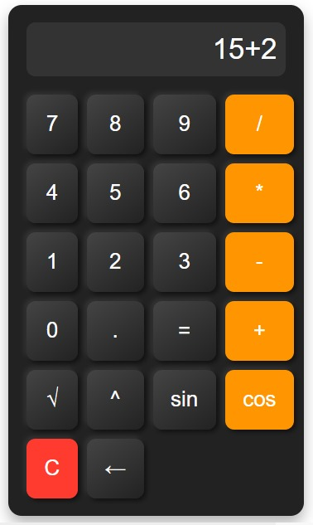

**RESULT:**

Thus, a scientific calculator is designed using JavaScript successfully and verified.

|  |  |
| --- | --- |
| **EXP NO:** **6** | **REGISTRATION FORM USING HTML, CSS, AND JAVASCRIPT VALIDATION** |
| **DATE:** **04/04/25** |

**AIM:**

To design a Registration Form using HTML, CSS (Bootstrap), and JavaScript validation.

**ALGORITHM:**

**Step 1:** Create the HTML structure with input fields for name, email, mobile, password, and confirm password.  
**Step 2:** Use Bootstrap and custom CSS to style the form and improve user interface.  
**Step 3:** Extract Head Size as X (independent variable) and Brain Weight as y (dependent variable).  
**Step 4:** Use regular expressions to validate name, email, mobile number, and password formats.  
**Step 5:** Check if password and confirm password fields match.  
**Step 6:** Display corresponding error messages for invalid inputs dynamically.  
**Step 7:** Prevent form submission if any validation fails and allow it if all inputs are valid.

**SOURCE CODE:**

<!DOCTYPE html>

<html lang="en">

<head>

<meta charset="UTF-8">

<meta name="viewport" content="width=device-width, initial-scale=1.0">

<title>Registration Form</title>

<link href="https://cdn.jsdelivr.net/npm/bootstrap@5.3.0/dist/css/bootstrap.min.css" rel="stylesheet">

<style>

body {

background-color: #f4f4f4;

font-family: Arial, sans-serif;

}

.container {

max-width: 450px;

background: #fff;

padding: 20px;

border-radius: 8px;

box-shadow: 0 0 10px rgba(0, 0, 0, 0.1);

margin-top: 50px;

}

.error {

color: red;

font-size: 14px;

}

</style>

</head>

<body>

<div class="container">

<h3 class="text-center">Registration Form</h3>

<form id="regForm" onsubmit="return validateForm()">

<div class="mb-3">

<label class="form-label">Full Name</label>

<input type="text" class="form-control" id="name">

<span class="error" id="nameError"></span>

</div>

<div class="mb-3">

<label class="form-label">Email</label>

<input type="email" class="form-control" id="email">

<span class="error" id="emailError"></span>

</div>

<div class="mb-3">

<label class="form-label">Mobile Number</label>

<input type="text" class="form-control" id="mobile">

<span class="error" id="mobileError"></span>

</div>

<div class="mb-3">

<label class="form-label">Password</label>

<input type="password" class="form-control" id="password">

<span class="error" id="passwordError"></span>

</div>

<div class="mb-3">

<label class="form-label">Confirm Password</label>

<input type="password" class="form-control" id="confirmPassword">

<span class="error" id="confirmPasswordError"></span>

</div>

<button type="submit" class="btn btn-primary w-100">Register</button>

</form>

</div>

<script>

function validateForm() {

let valid = true;

let name = document.getElementById("name").value.trim();

let email = document.getElementById("email").value.trim();

let mobile = document.getElementById("mobile").value.trim();

let password = document.getElementById("password").value;

let confirmPassword = document.getElementById("confirmPassword").value;

let nameRegex = /^[A-Za-z\s]{3,}$/;

let emailRegex = /^[a-zA-Z0-9._%+-]+@[a-zA-Z0-9.-]+\.[a-zA-Z]{2,}$/;

let mobileRegex = /^[6-9]\d{9}$/;

let passwordRegex = /^(?=.*[A-Za-z])(?=.*\d).{6,}$/;

document.getElementById("nameError").innerText = nameRegex.test(name) ? "" : "Name must be at least 3 letters";

document.getElementById("emailError").innerText = emailRegex.test(email) ? "" : "Invalid email format";

document.getElementById("mobileError").innerText = mobileRegex.test(mobile) ? "" : "Enter a valid 10-digit mobile number";

document.getElementById("passwordError").innerText = passwordRegex.test(password) ? "" : "Min 6 chars with at least one letter & number";

document.getElementById("confirmPasswordError").innerText = password === confirmPassword ? "" : "Passwords do not match";

return nameRegex.test(name) && emailRegex.test(email) && mobileRegex.test(mobile) && passwordRegex.test(password) && password === confirmPassword;

}

</script>

<script src="https://cdn.jsdelivr.net/npm/bootstrap@5.3.0/dist/js/bootstrap.bundle.min.js"></script>

</body>

</html>

**OUTPUT:**

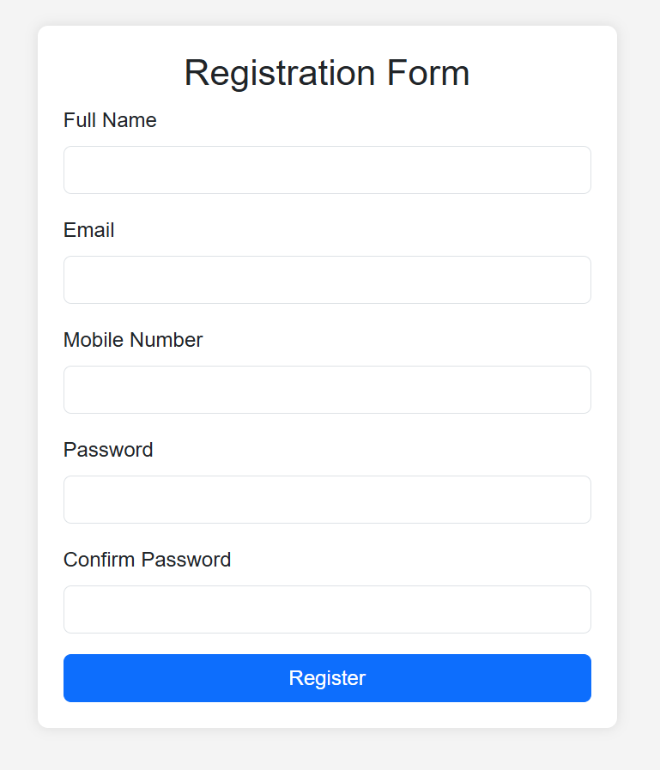

**RESULT:**

Thus, a registration form is designed using HTML,CSS and JavaScript successfully and verified.

|  |  |
| --- | --- |
| **EXP NO: 7** | **A SIMPLE WEB PAGE USING BOOTSTRAP** |
| **DATE:** **04/04/25** |

**AIM:**

To design a fully responsive and modern web page using Bootstrap 5 and Font Awesome with smooth animations and an elegant layout.

**ALGORITHM:**

**Step 1:** Start with the HTML5 boilerplate structure  
**Step 2:** Link Bootstrap CSS and Font Awesome icons from CDN  
**Step 3:** Design a navigation bar using Bootstrap's navbar component.  
**Step 4:** Create a hero section with a background image and animated welcome text.  
**Step 5:** Build a features section using Bootstrap cards to showcase highlights.  
**Step 6:** Create an image gallery using a Bootstrap grid layout with hover effects.  
**Step 7:** Add a contact section with a call-to-action button linked to an email.  
**Step 8:** Design a footer with social media icons and copyright information.  
**Step 9:** Use Bootstrap's utility classes and custom CSS for styling, hover effects, and responsiveness.  
**Step 10:** Link Bootstrap JavaScript at the bottom to enable collapsible navbar and other components.

**SOURCE CODE:**

<!DOCTYPE html>

<html lang="en">

<head>

<meta charset="UTF-8" />

<meta name="viewport" content="width=device-width, initial-scale=1" />

<title>Enhanced Responsive Web Page</title>

<link href="https://cdn.jsdelivr.net/npm/bootstrap@5.3.0/dist/css/bootstrap.min.css" rel="stylesheet">

<link href="https://cdnjs.cloudflare.com/ajax/libs/font-awesome/6.4.0/css/all.min.css" rel="stylesheet">

<style>

body {

font-family: 'Segoe UI', sans-serif;

scroll-behavior: smooth;

background-color: #f8f9fa;

}

.navbar {

box-shadow: 0 2px 5px rgba(0, 0, 0, 0.1);

}

.hero {

background: url('https://images.unsplash.com/photo-1519389950473-47ba0277781c') no-repeat center center/cover;

color: white;

padding: 120px 20px;

text-align: center;

animation: fadeIn 2s ease-in-out;

}

@keyframes fadeIn {

from { opacity: 0; transform: translateY(20px); }

to { opacity: 1; transform: translateY(0); }

}

.card:hover {

transform: translateY(-5px);

transition: transform 0.3s ease;

}

.feature-icon {

font-size: 2.5rem;

color: #0d6efd;

}

.gallery img {

width: 100%;

height: 250px;

object-fit: cover;

border-radius: 8px;

transition: transform 0.3s ease;

}

.gallery img:hover {

transform: scale(1.05);

}

.footer {

background-color: #343a40;

color: #fff;

padding: 30px 0;

}

.social-icons i {

font-size: 1.5rem;

margin: 0 10px;

color: white;

transition: color 0.3s;

}

.social-icons i:hover {

color: #0d6efd;

}

</style>

</head>

<body>

<!-- Navbar -->

<nav class="navbar navbar-expand-lg navbar-dark bg-primary sticky-top">

<div class="container">

<a class="navbar-brand" href="#">MySite</a>

<button class="navbar-toggler" type="button" data-bs-toggle="collapse" data-bs-target="#navbarNav">

<span class="navbar-toggler-icon"></span>

</button>

<div class="collapse navbar-collapse justify-content-end" id="navbarNav">

<ul class="navbar-nav">

<li class="nav-item"><a class="nav-link active" href="#home">Home</a></li>

<li class="nav-item"><a class="nav-link" href="#features">Features</a></li>

<li class="nav-item"><a class="nav-link" href="#gallery">Gallery</a></li>

<li class="nav-item"><a class="nav-link" href="#contact">Contact</a></li>

</ul>

</div>

</div>

</nav>

<!-- Hero Section -->

<section id="home" class="hero text-white">

<div class="container">

<h1 class="display-4 fw-bold">Welcome to My Beautiful Website</h1>

<p class="lead">Fully responsive. Smooth, modern design with animations and rich visuals.</p>

<a href="#features" class="btn btn-light mt-3">Explore Features</a>

</div>

</section>

<!-- Features Section -->

<section id="features" class="py-5">

<div class="container">

<h2 class="text-center mb-5">Amazing Features</h2>

<div class="row g-4">

<div class="col-md-4">

<div class="card text-center p-3 shadow-sm h-100">

<div class="card-body">

<i class="fas fa-laptop-code feature-icon mb-3"></i>

<h5 class="card-title">Responsive Design</h5>

<p class="card-text">Adapts beautifully to mobile, tablet, and desktop screens.</p>

</div>

</div>

</div>

<div class="col-md-4">

<div class="card text-center p-3 shadow-sm h-100">

<div class="card-body">

<i class="fas fa-magic feature-icon mb-3"></i>

<h5 class="card-title">Modern Animations</h5>

<p class="card-text">Smooth, eye-catching transitions for a sleek experience.</p>

</div>

</div>

</div>

<div class="col-md-4">

<div class="card text-center p-3 shadow-sm h-100">

<div class="card-body">

<i class="fas fa-bolt feature-icon mb-3"></i>

<h5 class="card-title">Fast & Lightweight</h5>

<p class="card-text">Minimal and optimized code for faster performance.</p>

</div>

</div>

</div>

</div>

</div>

</section>

<!-- Gallery Section -->

<section id="gallery" class="py-5 bg-light">

<div class="container">

<h2 class="text-center mb-5">Image Gallery</h2>

<div class="row g-4 gallery">

<div class="col-md-4"><img src="./alexa.avif" width="600" height="400" alt="Gallery Image"></div>

<div class="col-md-4"><img src="./coding.avif" width="600" height="400" alt="Gallery Image"></div>

<div class="col-md-4"><img src="./ai.webp" width="600" height="400" alt="Gallery Image"></div>

</div>

</div>

</section>

<!-- Contact Section -->

<section id="contact" class="py-5">

<div class="container text-center">

<h2 class="mb-4">Get in Touch</h2>

<p>Have questions or want to work together? Email me at <a href="mailto:hansi1122012@gmail.com">hansi1122012@gmail.com</a></p>

<a href="mailto:hansi1122012@gmail.com" class="btn btn-primary mt-2">Contact Now</a>

</div>

</section>

<!-- Footer -->

<footer class="footer text-center">

<div class="container">

<div class="social-icons mb-3">

<a href="#"><i class="fab fa-facebook-f"></i></a>

<a href="#"><i class="fab fa-twitter"></i></a>

<a href="#"><i class="fab fa-instagram"></i></a>

<a href="#"><i class="fab fa-github"></i></a>

</div>

<p class="mb-0">&copy; 2025 MySite. All rights reserved.</p>

</div>

</footer>

<!-- Bootstrap + Font Awesome -->

<script src="https://cdn.jsdelivr.net/npm/bootstrap@5.3.0/dist/js/bootstrap.bundle.min.js"></script>

</body>

</html>

**OUTPUT:**



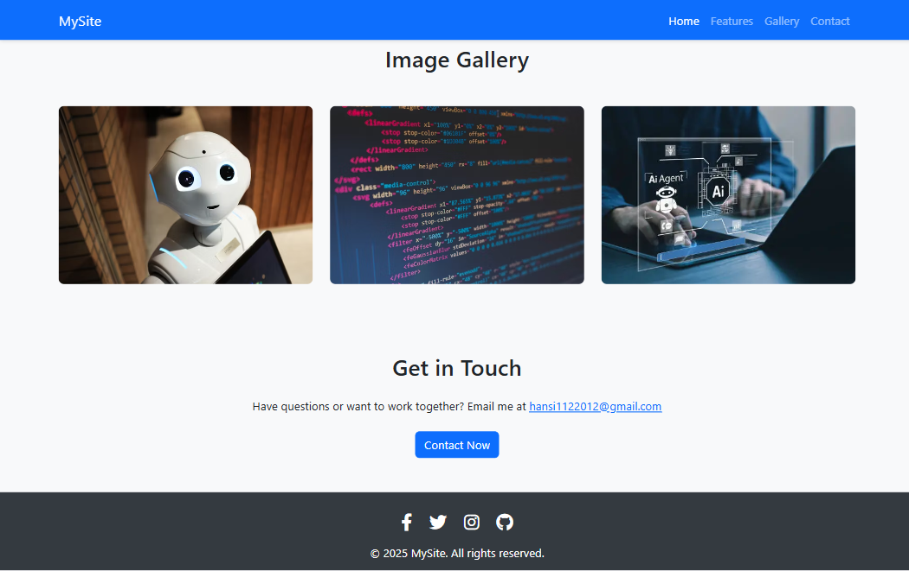

**RESULT:**

Thus, a fully responsive and visually appealing web page was successfully designed using Bootstrap 5 and verified.

|  |  |
| --- | --- |
| **EXP NO: 8** | **A RESPONSIVE WEB PAGE USING BOOTSTRAP'S GRID SYSTEM** |
| **DATE: 07/04/25** |

**AIM:**

To design a responsive web page using Bootstrap's grid system for adaptive layout.

**ALGORITHM:**

**Step 1:** Set up basic HTML structure with meta tags for responsiveness.  
**Step 2:** Include Bootstrap CSS and JS libraries.  
**Step 3:** Create a header with title and description.  
**Step 4:** Define a container for grid-based content.  
**Step 5:** Add a row with two columns for an image-text section.  
**Step 6:** Add a row with three equal-width columns for cards.  
**Step 7:** Add a row with four equal-width columns for smaller blocks.  
**Step 8:** Include footer with copyright information.  
**Step 9:** Test responsiveness across different screen sizes.

**SOURCE CODE:**

<!DOCTYPE html>

<html lang="en">

<head>

<meta charset="UTF-8" />

<meta name="viewport" content="width=device-width, initial-scale=1" />

<title>Bootstrap Grid Page</title>

<link href="https://cdn.jsdelivr.net/npm/bootstrap@5.3.0/dist/css/bootstrap.min.css" rel="stylesheet">

<style>

body {

font-family: 'Segoe UI', sans-serif;

}

.header {

background-color: #007bff;

color: white;

padding: 40px 0;

text-align: center;

}

.img-fluid {

border-radius: 8px;

}

.card:hover {

transform: translateY(-5px);

transition: 0.3s ease;

}

</style>

</head>

<body>

<!-- Header -->

<div class="header">

<h1>Bootstrap Grid System</h1>

<p>Responsive layout using rows and columns</p>

</div>

<!-- Grid Section -->

<div class="container py-5">

<!-- Row 1 -->

<div class="row mb-4">

<div class="col-md-6">

<img src="./ai.webp" width="600" height="400" alt="Tech Image" class="img-fluid">

</div>

<div class="col-md-6 d-flex align-items-center">

<div>

<h3>Responsive Columns</h3>

<p>This is a 2-column layout using Bootstrap’s grid. On smaller screens, it stacks vertically.</p>

</div>

</div>

</div>

<!-- Row 2 (3-column cards) -->

<div class="row text-center">

<div class="col-md-4 mb-4">

<div class="card shadow-sm h-100">

<div class="card-body">

<h5 class="card-title">Column One</h5>

<p class="card-text">This column spans 4/12 of the row on medium+ screens.</p>

</div>

</div>

</div>

<div class="col-md-4 mb-4">

<div class="card shadow-sm h-100">

<div class="card-body">

<h5 class="card-title">Column Two</h5>

<p class="card-text">Bootstrap handles spacing and responsiveness beautifully.</p>

</div>

</div>

</div>

<div class="col-md-4 mb-4">

<div class="card shadow-sm h-100">

<div class="card-body">

<h5 class="card-title">Column Three</h5>

<p class="card-text">Cards stay side by side or stack depending on screen width.</p>

</div>

</div>

</div>

</div>

<!-- Row 3 (4 columns) -->

<div class="row text-center">

<div class="col-sm-6 col-lg-3 mb-4">

<div class="p-3 bg-light border rounded">1/4 Width</div>

</div>

<div class="col-sm-6 col-lg-3 mb-4">

<div class="p-3 bg-light border rounded">1/4 Width</div>

</div>

<div class="col-sm-6 col-lg-3 mb-4">

<div class="p-3 bg-light border rounded">1/4 Width</div>

</div>

<div class="col-sm-6 col-lg-3 mb-4">

<div class="p-3 bg-light border rounded">1/4 Width</div>

</div>

</div>

</div>

<!-- Footer -->

<footer class="text-center py-4 bg-dark text-white">

&copy; 2025 Bootstrap Grid Demo

</footer>

<!-- Bootstrap Script -->

<script src="https://cdn.jsdelivr.net/npm/bootstrap@5.3.0/dist/js/bootstrap.bundle.min.js"></script>

</body>

</html>

**OUTPUT:**





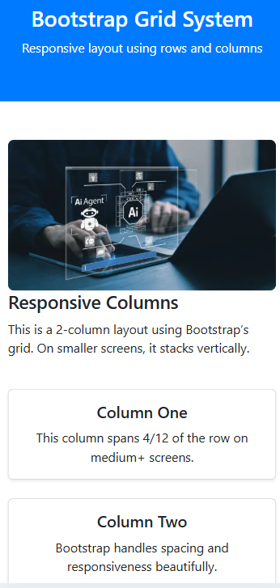 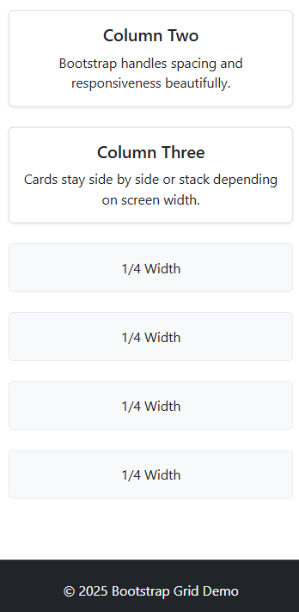 

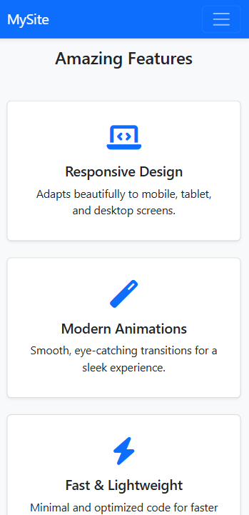  

**RESULT:** Thus, the python program to implement Single Layer Perceptron has been executed successfully.

|  |  |
| --- | --- |
| **EXP NO: 9** | **DESIGN A WEBPAGE WITH DROPDOWN, NAVIGATION BAR AND PAGINATION** |
| **DATE: 06/03/25** |

**AIM:**

To design a webpage with Dropdown, Navigation bar and Pagination.

**ALGORITHM:**

**Step 1:** Create a responsive HTML structure using Bootstrap 4 layout.  
**Step 2:** Add a dark-themed Bootstrap navbar with brand name and toggler. **Step 3:** Insert navbar links including Home, About, and a dropdown for Services. **Step 4:** Define dropdown items under Services using Bootstrap dropdown classes.  
**Step 5:** Add a container with welcome heading and paragraph content. **Step 6:** Insert Bootstrap pagination component with Previous, numbered pages, and Next. **Step 7:** Include Bootstrap and jQuery CDN links for styling and interactivity. **Step 8:** Add JavaScript to dynamically switch active pagination and update content.  
**Step 9:** Test navbar toggle, dropdown, and pagination functionality on various screen sizes.  
**Step 10**: Style and organize the layout using Bootstrap utility classes for clean design.

**SOURCE CODE:**

<!DOCTYPE html>

<html lang="en">

<head>

<meta charset="UTF-8">

<title>Perfect Webpage</title>

<meta name="viewport" content="width=device-width, initial-scale=1">

<link rel="stylesheet" href="https://maxcdn.bootstrapcdn.com/bootstrap/4.5.2/css/bootstrap.min.css">

<style>

body {

background-color: #f4f6f8;

font-family: 'Segoe UI', sans-serif;

}

.navbar {

box-shadow: 0 2px 6px rgba(0,0,0,0.1);

}

.item-card {

border: 1px solid #dee2e6;

border-radius: 10px;

padding: 20px;

background: white;

margin-bottom: 20px;

transition: 0.3s;

}

.item-card:hover {

box-shadow: 0 4px 12px rgba(0,0,0,0.1);

}

.pagination {

justify-content: center;

}

footer {

background: #343a40;

color: white;

padding: 20px 0;

text-align: center;

margin-top: 50px;

}

</style>

</head>

<body>

<!-- Navigation Bar -->

<nav class="navbar navbar-expand-lg navbar-dark bg-dark">

<a class="navbar-brand" href="#">MySite</a>

<button class="navbar-toggler" type="button" data-toggle="collapse" data-target="#navbarNav">

<span class="navbar-toggler-icon"></span>

</button>

<div class="collapse navbar-collapse" id="navbarNav">

<ul class="navbar-nav mr-auto">

<li class="nav-item active"><a class="nav-link" href="#">Home</a></li>

<li class="nav-item"><a class="nav-link" href="#">About</a></li>

<li class="nav-item dropdown">

<a class="nav-link dropdown-toggle" href="#" id="servicesDropdown" role="button" data-toggle="dropdown">

Services

</a>

<div class="dropdown-menu">

<a class="dropdown-item" href="#">Design</a>

<a class="dropdown-item" href="#">Development</a>

<a class="dropdown-item" href="#">SEO</a>

</div>

</li>

<li class="nav-item"><a class="nav-link" href="#">Contact</a></li>

</ul>

</div>

</nav>

<div class="container mt-5">

<h3 class="mb-4 text-center">Our Portfolio (Paginated Items)</h3>

<div id="item-list" class="row">

</div>

<nav>

<ul class="pagination" id="pagination">

</ul>

</nav>

</div>

<footer>

<div class="container">

<p>© 2025 MySite. All rights reserved.</p>

</div>

</footer>

<script src="https://code.jquery.com/jquery-3.5.1.slim.min.js"></script>

<script src="https://cdn.jsdelivr.net/npm/bootstrap@4.5.2/dist/js/bootstrap.bundle.min.js"></script>

<script>

const items = Array.from({ length: 24 }, (_, i) => `Item ${i + 1}`);

const itemsPerPage = 6;

let currentPage = 1

function renderItems() {

const start = (currentPage - 1) * itemsPerPage;

const end = start + itemsPerPage;

const currentItems = items.slice(start, end);

const itemList = document.getElementById('item-list');

itemList.innerHTML = '';

currentItems.forEach(item => {

const col = document.createElement('div');

col.className = 'col-md-4';

col.innerHTML = `

<div class="item-card">

<h5>${item}</h5>

<p>This is a short description for ${item}. Explore more about our awesome work.</p>

</div>`;

itemList.appendChild(col);

});

}

function renderPagination() {

const totalPages = Math.ceil(items.length / itemsPerPage);

const pagination = document.getElementById('pagination');

pagination.innerHTML = '';

// Previous Button

pagination.innerHTML += `

<li class="page-item ${currentPage === 1 ? 'disabled' : ''}">

<a class="page-link" href="#" onclick="changePage(${currentPage - 1})">Previous</a>

</li>`;

// Page Numbers

for (let i = 1; i <= totalPages; i++) {

pagination.innerHTML += `

<li class="page-item ${i === currentPage ? 'active' : ''}">

<a class="page-link" href="#" onclick="changePage(${i})">${i}</a>

</li>`;

}

// Next Button

pagination.innerHTML += `

<li class="page-item ${currentPage === totalPages ? 'disabled' : ''}">

<a class="page-link" href="#" onclick="changePage(${currentPage + 1})">Next</a>

</li>`;

}

function changePage(page) {

const totalPages = Math.ceil(items.length / itemsPerPage);

if (page >= 1 && page <= totalPages) {

currentPage = page;

renderItems();

renderPagination();

}

}

// Initial Load

renderItems();

renderPagination();

</script>

</body>

</html>

**OUTPUT:**

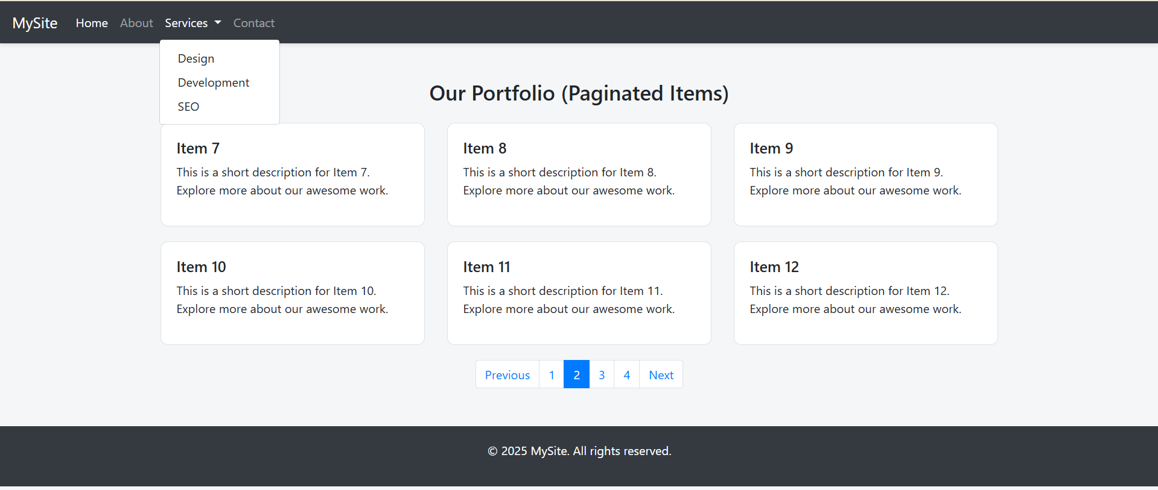

**RESULT:**

Thus, a webpage with Dropdown, Navigation bar and Pagination is designed successfully and verified.

|  |  |
| --- | --- |
| **EXP NO:** **10** | **DESIGN WEBPAGE USING JQUERY SELECTOR** |
| **DATE:** 27**/03/25** |

**AIM:**

To design a web page using jQuery selector.

**ALGORITHM:**

**Step 1:** Create a structured HTML layout with headings, paragraphs, and div elements having various classes and attributes.

**Step 2:** Include jQuery library and Google Fonts via CDN in the <head>.

**Step 3:** Define CSS styles for layout, typography, buttons, and highlight effects.

**Step 4:** Add multiple buttons with unique IDs to trigger different selector actions.

**Step 5:** Wrap all content inside a styled container for better presentation.

**Step 6:** Use $(document).ready() to ensure jQuery runs after the DOM loads.

**Step 7:** Use jQuery element selector to toggle highlights on all paragraphs.

**Step 8:** Use class, attribute, child, and pseudo selectors (e.g., .note, [data-custom], :nth-child, :not) to target specific elements.

**Step 9:** Assign click event handlers to each button to apply corresponding visual effects.

**SOURCE CODE:**

<!DOCTYPE html>

<html lang="en">

<head>

    <meta charset="UTF-8">

    <title>Advanced jQuery Selectors Demo</title>

    <script src="https://code.jquery.com/jquery-3.6.0.min.js"></script>

    <link href="https://fonts.googleapis.com/css2?family=Roboto&display=swap" rel="stylesheet">

    <style>

        body {

            font-family: 'Roboto', sans-serif;

            background-color: #f8f9fa;

            padding: 40px;

        }

        .container {

            max-width: 800px;

            margin: auto;

            background-color: #ffffff;

            padding: 30px;

            border-radius: 10px;

            box-shadow: 0 0 15px rgba(0,0,0,0.1);

        }

        h2, h3 {

            color: #343a40;

            margin-bottom: 20px;

        }

        p, div {

            font-size: 17px;

            margin-bottom: 10px;

        }

        .note {

            color: #6c757d;

            font-style: italic;

        }

        .highlight {

            background-color: yellow;

            font-weight: bold;

        }

        .custom {

            color: darkgreen;

            font-weight: bold;

        }

        .special {

            color: red;

            font-weight: bold;

        }

        button {

            padding: 10px 15px;

            margin: 10px 5px;

            background-color: #007bff;

            color: white;

            border: none;

            border-radius: 4px;

            cursor: pointer;

        }

        button:hover {

            background-color: #0056b3;

        }

    </style>

</head>

<body>

<div class="container">

    <h2>Advanced jQuery Selector Demonstration</h2>

    <p>This is the first paragraph.</p>

    <p class="note">This is a note paragraph.</p>

    <div>This is a general div.</div>

    <div data-custom="true">This div has a custom data attribute.</div>

    <h3 class="note">This is a heading with class "note".</h3>

    <div class="note">This is another note div.</div>

    <button id="highlightParagraphs">Highlight Paragraphs</button>

    <button id="highlightNotes">Highlight Notes</button>

    <button id="highlightCustom">Highlight Data Attribute</button>

    <button id="highlightNth">Highlight Every 2nd Paragraph</button>

    <button id="highlightNotNote">Highlight Non-Note Paragraphs</button>

    <button id="highlightChild">Highlight First Child Div</button>

</div>

<script>

    $(document).ready(function(){

        // Element selector

        $("#highlightParagraphs").click(function(){

            $("p").toggleClass("highlight");

        });

        // Class selector

        $("#highlightNotes").click(function(){

            $(".note").toggleClass("highlight");

        });

        // Attribute selector

        $("#highlightCustom").click(function(){

            $("[data-custom]").toggleClass("custom");

        });

        // nth-child selector

        $("#highlightNth").click(function(){

            $("p:nth-child(2)").toggleClass("special");

        });

        // not selector

        $("#highlightNotNote").click(function(){

            $("p:not(.note)").toggleClass("highlight");

        });

        // child selector

        $("#highlightChild").click(function(){

            $("div:first-child").toggleClass("special");

        });

    });

</script>

</body>

</html>

**OUTPUT:**

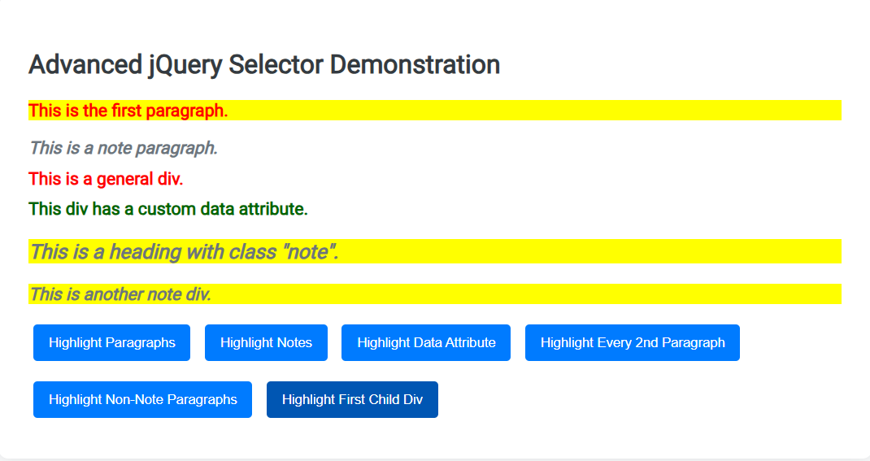

**RESULT:**

Thus, a web page using jQuery selector is designed successfully and verified.

|  |  |
| --- | --- |
| **EXP NO: 11** | **CREATE A SIMPLE WEB PAGE USING JQUERY EFFECTS** |
| **DATE:** **03/04/25** |

**AIM:**

To create a simple web page using jQuery Effects.

**ALGORITHM:**

**Step 1:** Start with a basic HTML structure including <head> and <body>.  
**Step 2:** Link jQuery and Google Fonts in the <head> section.  
**Step 3:** Style the layout using CSS for body, container, buttons, and effect box.  
**Step 4:** Create a centered container with a heading and multiple buttons for effects.  
**Step 5:** Add a <div> element (#effectBox) to show visual changes from jQuery.  
**Step 6:** Use $(document).ready() to initialize jQuery when the page is loaded.  
**Step 7:** Attach click() events to each button to trigger a specific jQuery effect like fadeToggle, slideUp, hide, show, etc.  
**Step 8:** Use animate() to apply combined width, height, and opacity transitions.  
**Step 9:** Use toggleClass() to switch styles dynamically for highlighting.

**SOURCE CODE:**

<!DOCTYPE html>

<html lang="en">

<head>

    <meta charset="UTF-8">

    <title>Advanced jQuery Effects</title>

    <script src="https://code.jquery.com/jquery-3.6.0.min.js"></script>

    <link href="https://fonts.googleapis.com/css2?family=Roboto&display=swap" rel="stylesheet">

    <style>

        body { font-family: 'Roboto', sans-serif;

            background: #f4f7fa;

            padding: 40px;

        }

        .container {

            max-width: 750px;

            margin: auto;

            background: #fff;

            padding: 30px;

            border-radius: 10px;

            box-shadow: 0 4px 15px rgba(0,0,0,0.1);

            text-align: center;

        }

        h2 { color: #333;

            margin-bottom: 25px;

        }

        button {

            margin: 10px;

            padding: 12px 20px;

            border: none;

            background-color: #007bff;

            color: #fff;

            border-radius: 6px;

            cursor: pointer;

            font-size: 15px;

            transition: 0.3s;

        }

        button:hover {

            background-color: #0056b3;

        }

        #effectBox {

            width: 100%;

            max-width: 500px;

            height: 150px;

            background: #d1ecf1;

            margin: 20px auto;

            padding: 20px;

            font-size: 18px;

            line-height: 1.5;

            border-radius: 8px;

            box-shadow: 0 4px 10px rgba(0,0,0,0.1);

            transition: all 0.4s ease-in-out;

        }

        .highlighted {

            background-color: #ffc107 !important;

            color: #000;

            transform: scale(1.05);

        }

    </style>

</head>

<body>

<div class="container">

    <h2>Advanced jQuery Effects</h2>

    <button id="fadeToggle">Fade Toggle</button>

    <button id="fadeIn">Fade In</button>

    <button id="fadeOut">Fade Out</button>

    <button id="slideToggle">Slide Toggle</button>

    <button id="slideUp">Slide Up</button>

    <button id="slideDown">Slide Down</button>

    <button id="hide">Hide</button>

    <button id="show">Show</button>

    <button id="toggle">Toggle</button>

    <button id="animateBtn">Animate</button>

    <button id="highlightBtn">Highlight Toggle</button>

    <div id="effectBox">

        This is a dynamic content box. Click any button above to try different effects!

    </div>

</div>

<script>

    $(document).ready(function(){

        $("#fadeToggle").click(function(){

            $("#effectBox").fadeToggle("slow");

        });

        $("#fadeIn").click(function(){

        $("#effectBox").fadeIn("slow");

        });

        $("#fadeOut").click(function(){

            $("#effectBox").fadeOut("slow");

        });

        $("#slideToggle").click(function(){

            $("#effectBox").slideToggle("slow");

        });

        $("#slideUp").click(function(){

            $("#effectBox").slideUp("slow");

        });

        $("#slideDown").click(function(){

            $("#effectBox").slideDown("slow");

        });

        $("#hide").click(function(){

            $("#effectBox").hide("slow");

        });

        $("#show").click(function(){

            $("#effectBox").show("slow");

        });

        $("#toggle").click(function(){

            $("#effectBox").toggle("slow");

});

        $("#animateBtn").click(function(){

            $("#effectBox").animate({

                width: "toggle",

                height: "toggle",

                opacity: "toggle"

            }, 1000);

        });

        $("#highlightBtn").click(function(){

            $("#effectBox").toggleClass("highlighted");

        });

    });

</script>

</body>

</html>

**OUTPUT:**

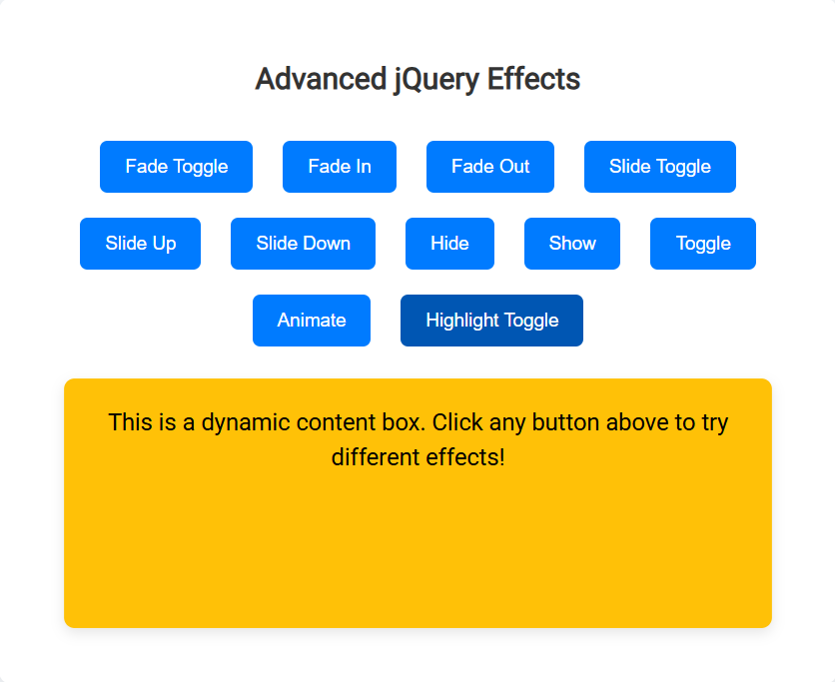

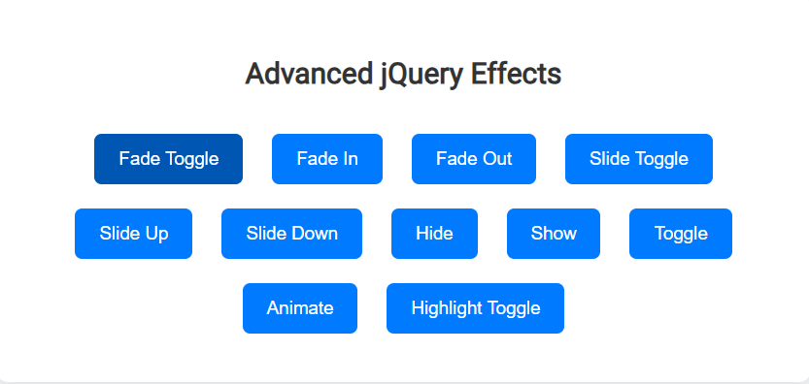

**RESULT:**

Thus, a simple web page was successfully designed using jQuery effects and verified.

|  |  |
| --- | --- |
| **EXP NO: 12** | **DESIGN A WEB PAGE TO CALCULATE FACTORIAL OF A NUMBER USING PHP** |
| **DATE: 10/04/25** |

**AIM:**

To design a web page to calculate factorial of a number using PHP.

**ALGORITHM:**

**Step 1:** Create an HTML form to accept a number as input from the user.  
**Step 2:** Set the form's method to POST and action to the same PHP file.  
**Step 3:** Check if the form is submitted using $_SERVER["REQUEST_METHOD"] == "POST".  
**Step 4:** Retrieve the input number using $_POST["num"].  
**Step 5:** Initialize a variable factorial to 1.  
**Step 6:** If the input number is negative, display an error message.  
**Step 7:** Otherwise, use a for loop to multiply numbers from 1 to the input number.  
**Step 8:** After the loop ends, display the calculated factorial result.  
**Step 9:** Embed the PHP code below the HTML form to process and display the result on the same page.

**SOURCE CODE:**

<!DOCTYPE html>

<html lang="en">

<head>

    <meta charset="UTF-8">

    <title>Factorial Calculator</title>

    <style>

        body {

            font-family: 'Segoe UI', sans-serif;

            background-color: #f0f8ff;

            display: flex;

            justify-content: center;

            align-items: center;

            height: 100vh;

        }

        .container {

            background-color: white;

            padding: 30px 40px;

            border-radius: 10px;

            box-shadow: 0 0 15px rgba(0,0,0,0.2);

            text-align: center;

            width: 350px;

        }

        h2 {

            color: #007bff;

            margin-bottom: 20px;

        }

        input[type="number"] {

            width: 80%;

            padding: 10px;

            margin-bottom: 15px;

            border-radius: 5px;

            border: 1px solid #ccc;

            font-size: 16px;

        }

        input[type="submit"] {

            background-color: #007bff;

            color: white;

            border: none;

            padding: 10px 20px;

            font-size: 16px;

            border-radius: 5px;

            cursor: pointer;

        }

        input[type="submit"]:hover {

            background-color: #0056b3;

        }

        .result {

            margin-top: 20px;

            font-size: 18px;

            font-weight: bold;

            color: green;

        }

        .error {

            color: red;

        }

    </style>

</head>

<body>

    <div class="container">

        <h2>Factorial Calculator</h2>

        <form method="post" action="">

            <input type="number" name="num" placeholder="Enter a number" required>

            <br>

            <input type="submit" value="Calculate">

        </form>

        <?php

        if ($_SERVER["REQUEST_METHOD"] == "POST") {

            $num = $_POST["num"];

            if (!is_numeric($num)) {

                echo "<div class='error'>Please enter a valid number.</div>";

            } elseif ($num < 0) {

                echo "<div class='error'>Factorial is not defined for negative numbers.</div>";

            } else {

                $factorial = 1;

                for ($i = 1; $i <= $num; $i++) {

                    $factorial *= $i;

                }

                echo "<div class='result'>Factorial of $num is $factorial</div>";

            }

        }

        ?>

    </div>

</body>

</html>

**OUTPUT:**

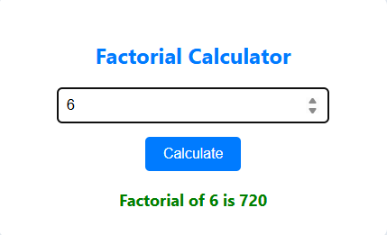



**RESULT:**

Thus, designing a web page to calculate factorial of a number using PHP has been executed successfully.

|  |  |
| --- | --- |
| **EXP NO: 13** | **CREATE A WEB PAGE TO PERFORM ARITHMETIC OPERATIONS USING PHP** |
| **DATE: 10/04/25** |

**AIM:**

To create a webpage to perform arithmetic operations using PHP.

**ALGORITHM:**

**Step 1:** Start  
**Step 2:** Display a form to input two numbers and select an operation (Add, Subtract, Multiply, Divide).  
**Step 3:** Wait for user to submit the form using the submit button.  
**Step 4:** Retrieve input values num1, num2, and operation from the form  
**Step 5:** Validate inputs to ensure both numbers are numeric  
**Step 6:** Use switch-case to perform the selected arithmetic operation  
**Step 7:** Handle division by zero if the operation is division  
**Step 8:** **Display the result** on the same page  
**Step 9:** End

**SOURCE CODE:**

<!DOCTYPE html>

<html lang="en">

<head>

<meta charset="UTF-8">

<title>Arithmetic Calculator</title>

<style>

body {

font-family: Arial, sans-serif;

background-color: #f4f6f9;

padding: 50px;

}

.calculator {

background: #fff;

padding: 30px;

max-width: 400px;

margin: auto;

border-radius: 10px;

box-shadow: 0 0 15px rgba(0,0,0,0.2);

}

h2 {

text-align: center;

margin-bottom: 20px;

color: #333;

}

input[type="number"], select {

width: 100%;

padding: 10px;

margin: 10px 0;

border: 1px solid #ccc;

border-radius: 5px;

}

input[type="submit"] {

background-color: #28a745;

color: white;

padding: 12px;

border: none;

width: 100%;

border-radius: 5px;

cursor: pointer;

}

input[type="submit"]:hover {

background-color: #218838;

}

.result {

margin-top: 20px;

text-align: center;

font-weight: bold;

color: #007bff;

}

.error {

color: red;

font-weight: bold;

text-align: center;

}

</style>

</head>

<body>

<div class="calculator">

<h2>Arithmetic Calculator</h2>

<form method="post" action="">

Number 1:

<input type="number" name="num1" step="any" required>

Number 2:

<input type="number" name="num2" step="any" required>

Operation:

<select name="operation" required>

<option value="">--Select Operation--</option>

<option value="add">Addition (+)</option>

<option value="sub">Subtraction (-)</option>

<option value="mul">Multiplication (×)</option>

<option value="div">Division (÷)</option>

</select>

<input type="submit" value="Calculate">

</form>

<?php

if ($_SERVER["REQUEST_METHOD"] == "POST") {

$num1 = $_POST["num1"];

$num2 = $_POST["num2"];

$op = $_POST["operation"];

if (!is_numeric($num1) || !is_numeric($num2)) {

echo "<div class='error'>Please enter valid numbers.</div>";

} else {

switch($op) {

case "add": $res = $num1 + $num2; break;

case "sub": $res = $num1 - $num2; break;

case "mul": $res = $num1 * $num2; break;

case "div":

if ($num2 != 0) {

$res = $num1 / $num2;

} else {

$res = "Cannot divide by zero";

}

break;

default: $res = "Invalid operation";

}

echo "<div class='result'>Result: $res</div>";

}

}

?>

</div>

</body>

</html>

**OUTPUT:**

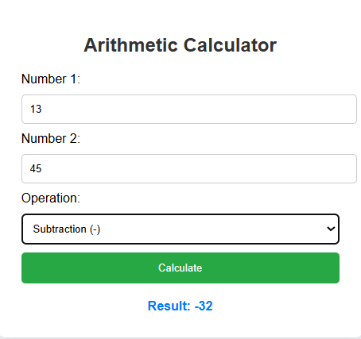

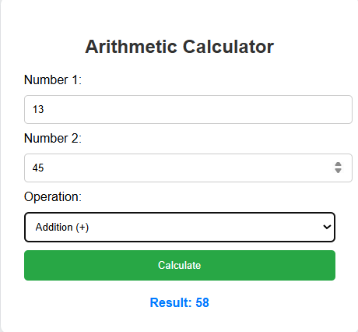

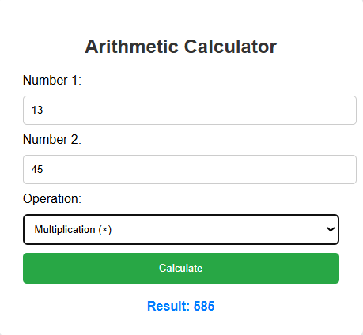

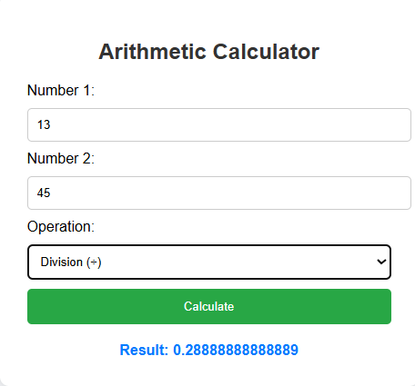

**RESULT:**

Thus, a webpage to perform arithmetic operations using PHP has been executed successfully.

|  |  |
| --- | --- |
| **EXP NO: 15** | **PHP PROGRAM USING REGULAR EXPRESSIONS** |
| **DATE: 26/04/25** |

**AIM:**

To design and implement a PHP-based web form that validates user inputs using regular expressions and logic checks.

**ALGORITHM:**

**Step 1:** Start the HTML form and accept input fields for username, DOB, mobile, Aadhar, password, PIN code, and PAN number.  
**Step 2:** On form submission, collect form data using the $_POST method in PHP.  
**Step 3:** Initialize an empty array to store validation error messages.  
**Step 4:** Validate the username using a regular expression to allow 4–15 characters (letters, digits, underscores).  
**Step 5:** Calculate the user's age from DOB and check if it is 18 or above.  
**Step 6:** Validate the mobile number to ensure it starts with 6–9 and is 10 digits long.  
**Step 7:** Validate the Aadhar number to ensure it has exactly 12 digits.  
**Step 8:** If no validation errors, display a success message; otherwise, display all error messages.

**SOURCE CODE:**

<!DOCTYPE html>

<html>

<head>

<title>Enhanced Form Validation</title>

<style>

body {

font-family: Arial;

padding: 20px;

}

.error {

color: red;

}

.success {

color: green;

}

</style>

</head>

<body>

<h2>User Registration Form</h2>

<form method="post">

Username: <input type="text" name="username"><br><br>

Date of Birth: <input type="date" name="dob"><br><br>

Mobile Number: <input type="text" name="mobile"><br><br>

Aadhar Number: <input type="text" name="aadhar"><br><br>

Password: <input type="password" name="password"><br><br>

PIN Code: <input type="text" name="pincode"><br><br>

PAN Number: <input type="text" name="pan"><br><br>

<input type="submit" name="submit" value="Submit">

</form>

<?php

if (isset($_POST['submit'])) {

$username = $_POST['username'];

$dob = $_POST['dob'];

$mobile = $_POST['mobile'];

$aadhar = $_POST['aadhar'];

$password = $_POST['password'];

$pincode = $_POST['pincode'];

$pan = $_POST['pan'];

$errors = [];

// Username (4-15 characters, letters, digits, _)

if (!preg_match('/^[a-zA-Z0-9_]{4,15}$/', $username)) {

$errors[] = "Invalid Username";

}

// DOB (age must be 18+)

$today = new DateTime();

$birthDate = new DateTime($dob);

$age = $today->diff($birthDate)->y;

if ($age < 18) {

$errors[] = "You must be at least 18 years old.";

}

// Mobile

if (!preg_match('/^[6-9]\d{9}$/', $mobile)) {

$errors[] = "Invalid Mobile Number";

}

// Aadhar

if (!preg_match('/^\d{12}$/', $aadhar)) {

$errors[] = "Invalid Aadhar Number";

}

// Password (min 6 chars, at least 1 letter and 1 number)

if (!preg_match('/^(?=.*[A-Za-z])(?=.*\d)[A-Za-z\d]{6,}$/', $password)) {

$errors[] = "Password must be at least 6 characters with letters and numbers";

}

// PIN Code

if (!preg_match('/^[1-9][0-9]{5}$/', $pincode)) {

$errors[] = "Invalid PIN Code";

}

// PAN Number

if (!preg_match('/^[A-Z]{5}[0-9]{4}[A-Z]{1}$/', $pan)) {

$errors[] = "Invalid PAN Number";

}

// Output

if (empty($errors)) {

echo "<p class='success'>All inputs are valid!</p>";

} else {

foreach ($errors as $error) {

echo "<p class='error'>$error</p>";

}

}

}

?>

</body>

</html>

**OUTPUT:**

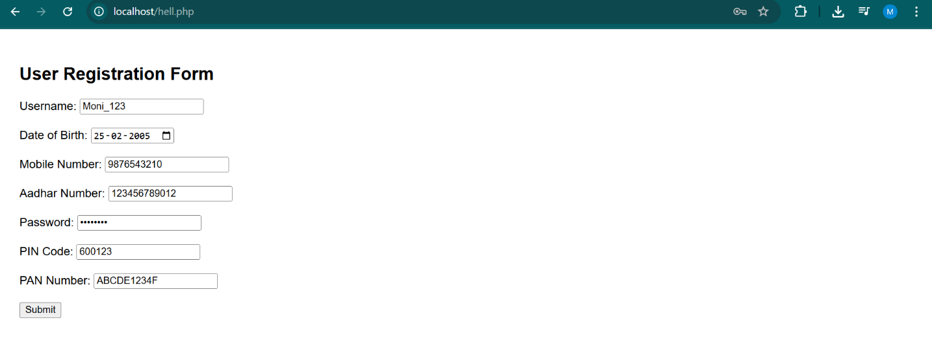

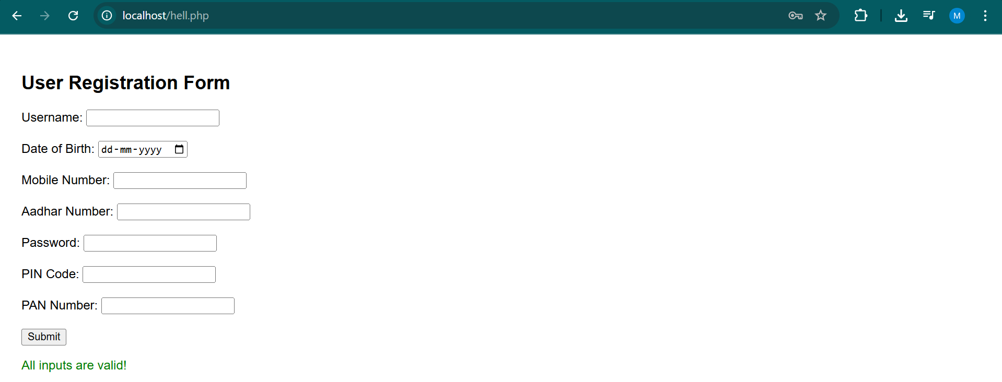

**RESULT:**

The PHP script successfully validates all user inputs and provides appropriate error or success messages based on the entered data.